**Login in Instagram**

1. Open Instagram’s official website

* URL OF INSTAGRAM’S WEBSITE: https://www.instagram.com/

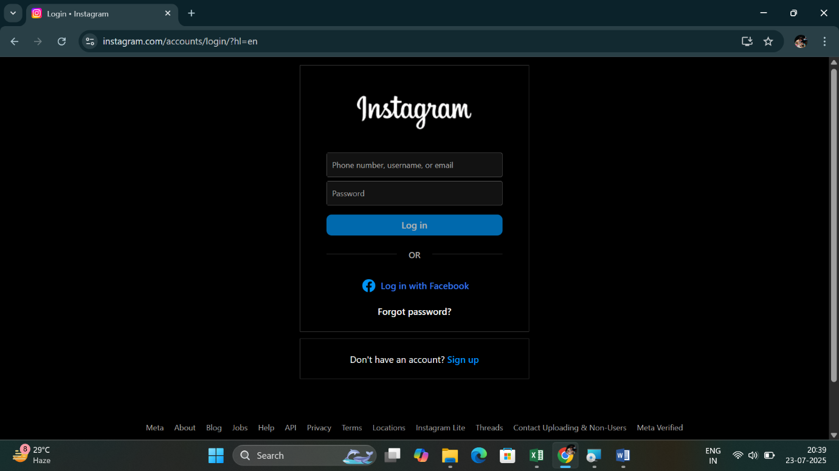

1. 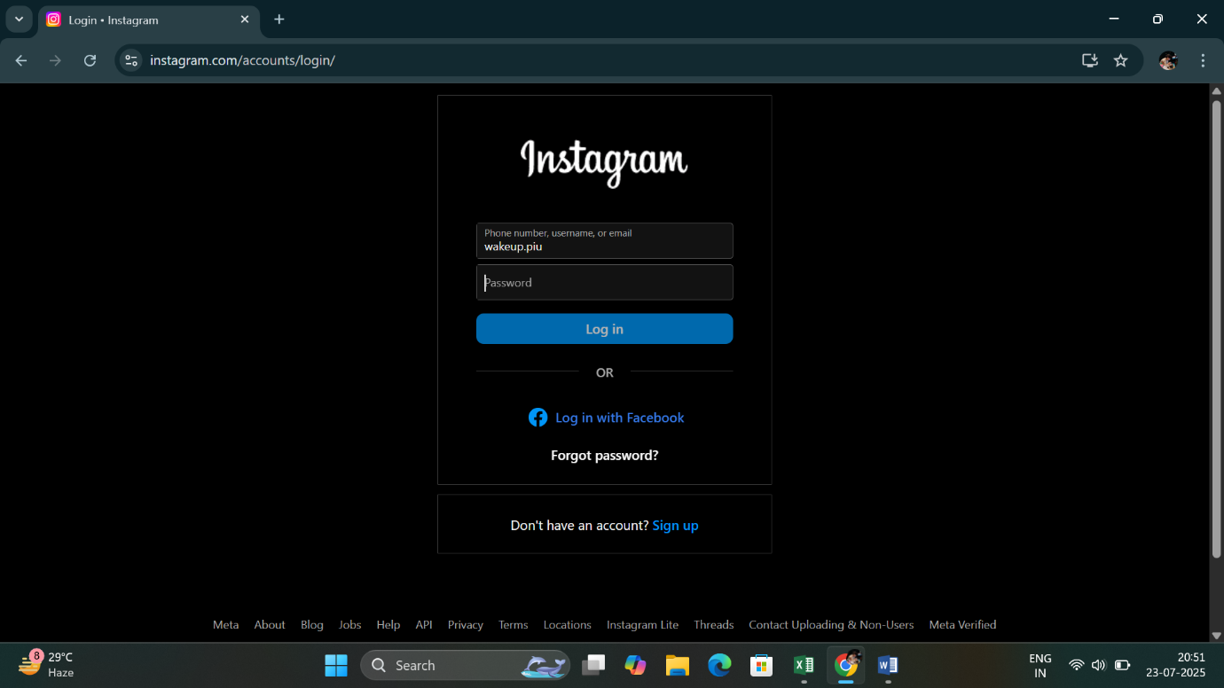Enter username

* Type in your valid Instagram username in the username field.

1. Enter Password

* 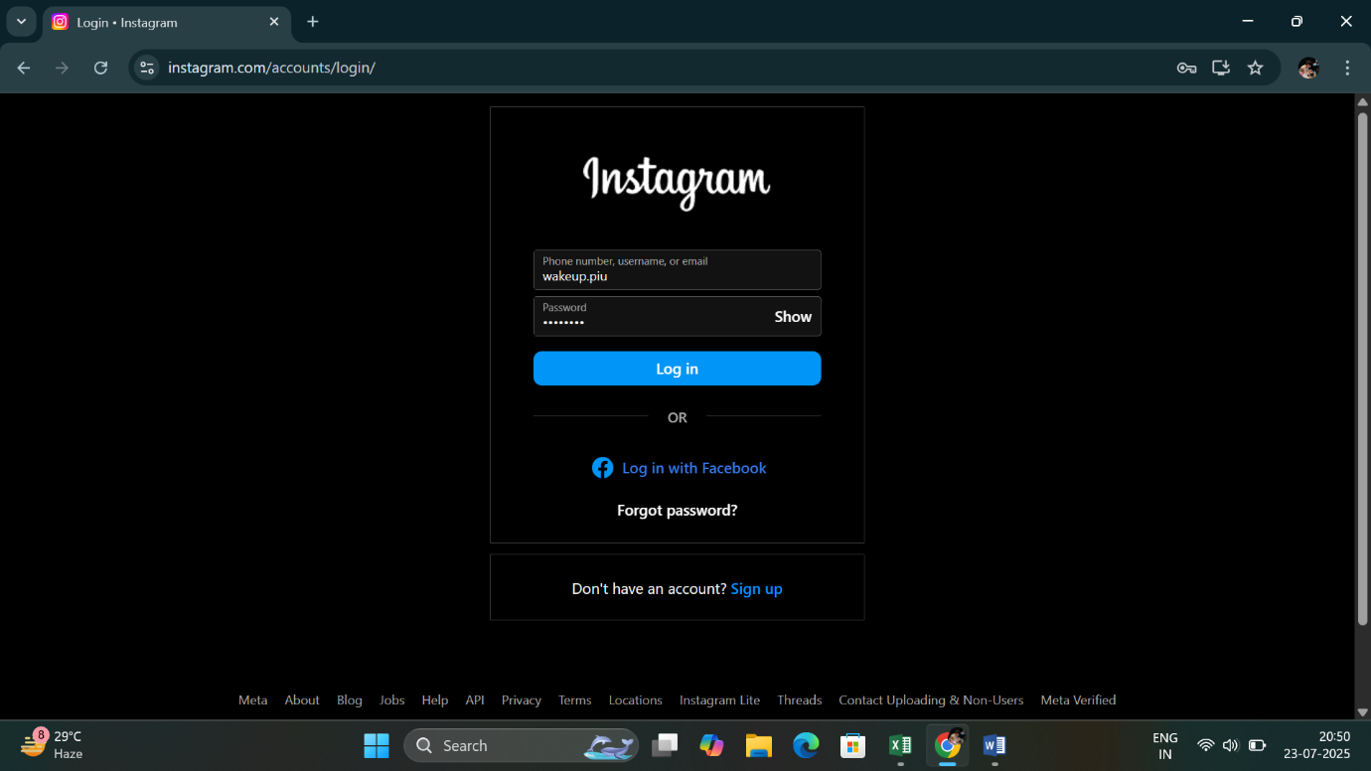Input your correct password into the password field.

1. Click on the “Log In” Button

* Hit that blue “**Log In”** button to proceed.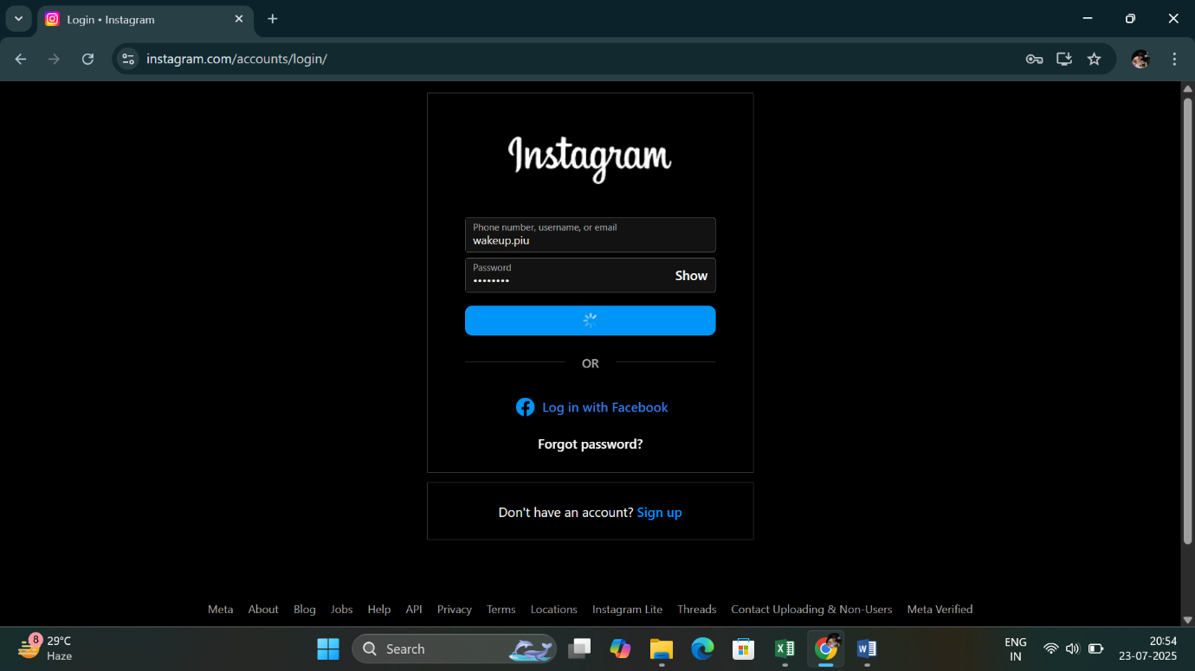

1. (Optional) Handle Two-Factor Authentication

* If you’ve enabled two-step verification, you’ll receive a code via SMS or email.  
  Enter the code in the verification field.

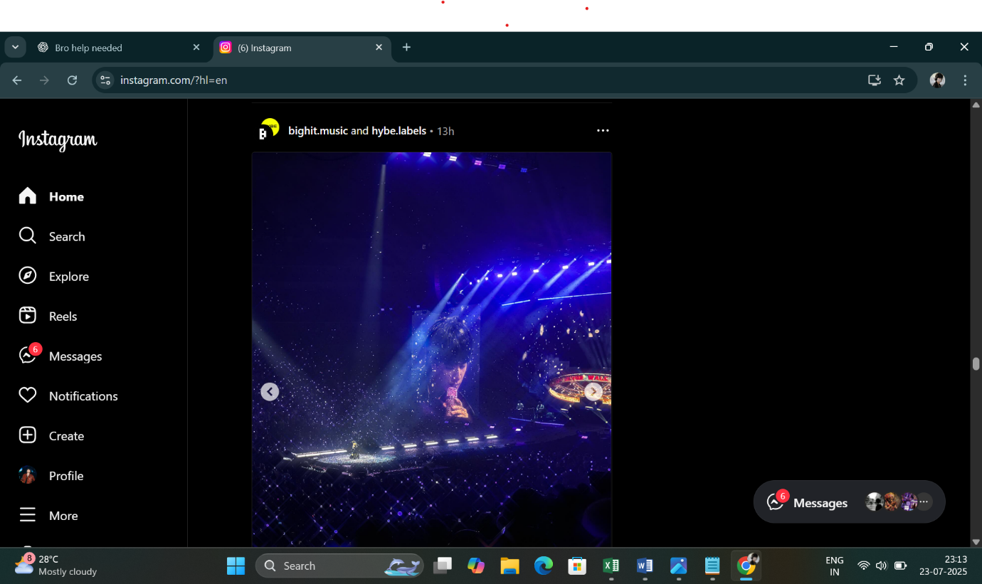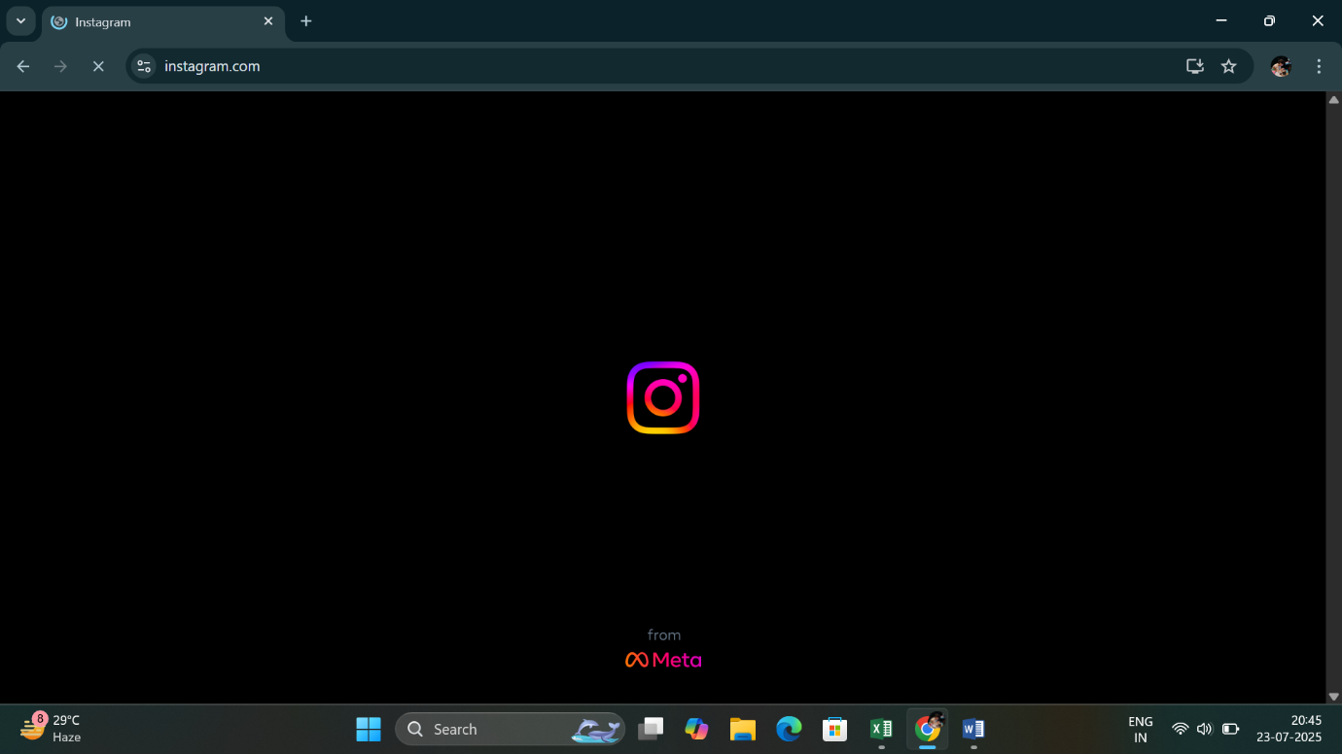

1. Welcome to Your Feed!

* If everything’s correct, you’ll be taken straight to your Instagram home screen where all the vibes live.

**Login Validation**

1. Incorrect Credentials? Get an Error Message

* If the **username or password is incorrect**, Instagram will show a red error message that says:

*"Sorry, your password was incorrect. Please double-check your password."*

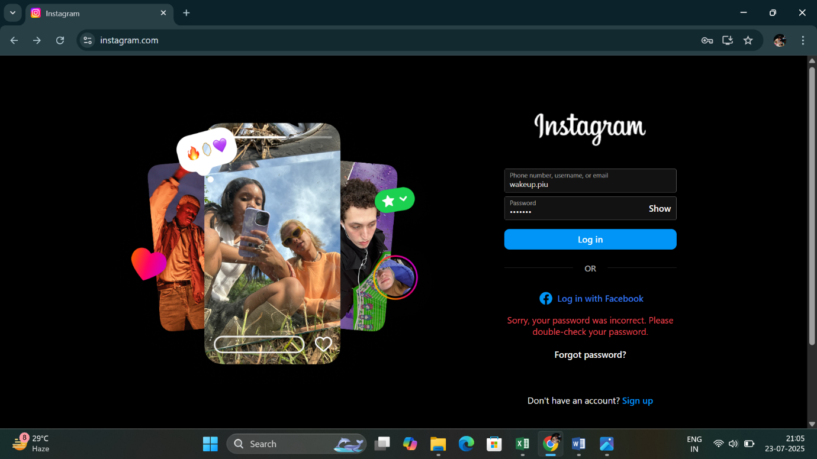Like shown below:

* This means you need to re-enter your correct login details. You can also click on “**Forgot password?**” to reset your password.